From our Director, Alan S. Lipp, M.D…
Hello. I hope everyone had a wonderful summer. We are very excited about some of the upcoming events related to the Celiac Program. In this newsletter, you will see the upcoming schedule of some more interesting lectures. We are happy to welcome Marlisa Brown, a popular dietician who is very knowledgeable about celiac disease and the gluten-free diet, to our roster of speakers. I also wanted to point out that we are now coordinating with our friends at the Gluten Intolerance Group of Long Island so that our meetings do not conflict with each other. As many of you know, I have been approached to participate in clinical trials of potential medications for celiac disease. While the first trial that I discussed may not be happening (it is on hold for now), there is a different very exciting trial that I may become involved with. I will of course keep you posted once I am looking to enroll participants.
I wanted to share with you some recent studies pertaining to celiac disease.
In a rather exciting study for the future of celiac disease, researchers at Stanford University have found a way to “turn off the switch” that may be responsible for the activation of celiac disease. It is known that an enzyme called transglutaminase 2 (TG2) is inactive in a healthy small intestine but active in those with celiac disease. The researchers found another enzyme called ERp57 that switches off TG2 outside the cell. They are now starting to look into existing drugs that may be able to target this newly discovered “switch”. This could be a very promising discovery but there is much to be studied and understood. Stay tuned!
A Danish study found that women with undiganosed celiac disease may be more likely to have miscarriages or stillbirths than women who do not have the disease. They found that those with undiagnosed celiac disease were 12% more likely to have miscarriages and 62% more likely to experience a stillbirth. The good news…Once celiac disease is identified and treated with a gluten-free diet, the women’s risk of pregnancy complications returns to normal levels.
A recent database analysis presented at the World Congress of Gastroenterology looked at 15,000 patients with eosinophilic esophagitis, a disorder that causes difficulties with swallowing, and found that 2% had celiac disease, a surprisingly high number. This suggests a relationship between the two diseases. They are now looking to see if the reverse is true. Do patients with celiac disease have a higher incidence of eosinophilic esophagitis?
An article published in Gastroenterology by our colleagues at Columbia University found that 1 in 31 patients with an iron deficiency anemia had evidence of celiac disease. This confirms our belief that testing for celiac disease should be part of any evaluation of iron deficiency anemia.
And lastly, something for celiac patients to be excited about but only for a rare treat. Dunkin Donuts is now beginning to sell a certified gluten-free, individually wrapped fudge brownie. But beware-it has 350 calories and 34 grams of sugar!
Wishing everyone the best…
Alan S. Lipp, M.D., FACG, FACP

Overview of June Celiac Lecture
Dr. Michael Pettei, Chief of Gastroenterology at Cohen Children’s Hospital spoke at ECLI on June 6. His stimulating talk gave a Pediatrician’s perspective of Celiac Disease (CD). It was well attended and Dr. Pettei was gracious in staying over an hour following his talk answering many questions.
The talk emphasized the clinical presentation, pathology and importance of diet. Origninally Celiac Disease (CD) was viewed as a disease of symptomatic children of European ancestry. It is now recognized that not all patients are symptomatic, it manifests at any age and is seen worldwide.
Dr. Pettei stressed the importance of a child adhering to life style changes and a strict gluten free diet. He mentioned the association of CD in patients with Type 1 Diabetes, Thyroid Disease, Down Syndrome and Turner Syndrome. Since CD is a genetic disorder screening of first degree relatives was recommended.
Although a strict gluten free diet is the treatment for CD, Dr. Pettei discussed clinical trials with oral medication and also a vaccine. The attendees were happy to hear about these studies knowing that here may be relief in the future.

2018 – 2019 Celiac Lecture Series

The Endoscopy Center of Long Island is pleased to announce its Celiac lecture series. This lecture series is open for the public. We invite our friends in the community to attend.

Lectures are held on Wednesday evenings from 7:00PM – 8:00PM. Details are below.

Date | Title | Presenter
9/26/2018 | Emerging Therapies for Celiac Disease – Help is on the Way | Alan Lipp, MD, FACG, FACP  Director, Celiac Center of Long Island
11/28/2018 | Gluten-Free Holiday Recipes | Barbara Callanan, MS CIA Trained Celiac Chef
4/10/2019 | Quick and Easy Ways to Make Your Favorite Recipes Gluten-Free | Marlisa Brown, MS, RDN, CDE, CDN  Celiac Dietician and Author
Lectures are held at ECLI. Refreshments will be served. 711 Stewart Ave.
Suite 114
Garden City, NY 11530 www.ecliny.com
(516) 227-3254

Please send your RSVP 2 days in advance of the lecture to cme@ecliny.co
Simple Tips When Dining Out Gluten-Free
By Marlisa Brown MS RD CDE CDN 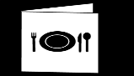

In order to make sure you have a pleasant dining experience, try to call restaurants (or look them up online) prior to your visit and get a copy of their menu. When you call, ask to speak to the manager and be sure to call off-hours (for example, the middle of the afternoon, after lunch rush and before dinner service); when they are not busy, and they will be able to talk to you withoout being rushed, ask for the manager if available. Selecting your meal will always be easier if you have identified gluten-free foods prior to your arrival at the restaurant. A night out is supposed to be fun, and it shouldn’t feel like a chore. Some restaurants are clearly more amenable to special requests than others, so try to choose those whenever you can. It’s a win-win when you give your business to establishments that make you feel most welcome.
It’s a given that, at times, your restaurant experience may be rocky—be patient. And when you have a great meal, show the chef and wait staff that you appreciate it by thanking them and tipping generously. The following list offers many suggestions to make it easier for you when ordering gluten-free choices.
SIMPLE TIPS WHEN DINING OUT
- Check with local celiac support groups for restaurant suggestions.
- Select restaurants that have gluten-free menus; and be sure to ask questions about possible cross contamination. (Pasta water, shared fryer, shared toaster, condiment contamination).
- Review the restaurant’s menu ahead of time and find some items you feel confident about.
- Call ahead and speak to the manager or chef to find out whether they can provided you with safe and delicious selections. Call in the middle of the afternoon, when they are more likely to be slow and can answer all your questions.
- Try to avoid restaurants that may have a higher risk of overall cross-contamination, such as those who prepare bakery items in the same area where other foods are being made or those with very small busy kitchens.
- It takes more care for a restaurant to prevent cross-contaminiation, so try to dine out when the restaurant is less busy, either early or late in the evening.
- Bring a copy of the gluten-free dining sheets with you to make it easier for the chef to provide you with safe selections. Fell free to print off copies at my blog glutenfreeEZ.com
- If it appears they are not taking you seriously explain to the server that you will become ill if particular care is not taken with your food. Sometimes it is important to ask to speak with the chef.
- Send back food that has been contaminated with gluten, breadcrumbs, croutons, etc. Let them know that removing or scraping off the problem food will not be enough to keep you from getting sick and that you are not just doing this as a lifestyle change.
- Read reviews that others have posted about their gluten-free experiences. There are many on the App find me gluten free.
- Once you find restaurants that you really enjoy safely make sure you compile a list so you have many places to frequent.
Some recipes from my “GLUTEN FREE HASSLE FREE COOKBOOK”
Cannoli Cones Serves 12
- Gluten-free ice cream cones are a perfect alternative to cannoli shell.
- 1 pound whole milk ricotta cheese
- 1 cup powdered sugar
- 1 tsp pure vanilla extract
- 3 Tbsp mini semi sweet chocolate chips
- 12 small gluten-free ice cream cones
- 1. Blend ricotta, powdered sugar, and mini chocolate chips.
- 2. Use an ice cream scoop to fill in cones and serve.
- Nutritional Information: 124 calories, 4.3 grams protein, 13.2 grams carbohydrates, 5.7 grams fat, 19.2 milligrams cholesterol, 36.2 milligrams sodium, <1 gram fiber, 79.2 milligrams calcium, <1 milligram iron
- Tip: Cocoa powder can be mixed with filling to make it really chocolaty.
- Quick and Easy;
- **Allergy Tip: GF, EF, NF, PF, FF, SFF, V. Double check the cones you purchase to make sure they are egg free and nut free. To make soy free double check the cones, and use gluten free soy free chocolate chips.
Cream Puffs Makes 18
- Light, airy and delicious – fill with whipped cream, pastry cream or ice cream.
- 1 cup (8 oz) water
- ½ cup unsalted butter
- ¾ cup white rice flour
- ¼ cup tapioca flour
- ½ tsp sea salt
- ¼ tsp xanthan gum
- ¼ tsp gluten-free baking powder
- 4 eggs
- 1 cup heavy whipping cream
- 3 Tbsp powdered sugar
- 1 tsp pure vanilla extract
- 1. Preheat oven to 400 degrees F. Line two baking sheets with parchment paper.
- 2. Combine the water and butter in a medium-sized saucepan, heat until butter is melted, and bring to a boil.
- 3. Sift together rice flour, tapioca flour, salt, gum and baking powder. Add to butter mixture and stir constantly until mixture rolls into a ball and leaves the side of the pan. This should take less than a minute. Remove from heat and cool for 5 minutes.
- 4. Add eggs, one at a time, beating well after each addition.
- 5. Drop by rounded tablespoons onto prepared baking sheets. Bake for 20 to 25 minutes until light golden brown. Remove from oven and cool.
- 6. To make cream filling: pour the cream and vanilla into a mixing bowl and begin to whip on high speed. Sprinkle in 2 tablespoons of sugar gradually as the cream whips. Whip until stiff, but be careful not to over whip.
- 7. Cut tops off cream puffs. Fill bottom with cream, then replace tops. Sprinkle with remaining 1 tablespoon confectioner’s sugar and serve.
- Nutrition information: 141 calories, 2.1 grams protein, 8 grams carbohydrates, 11.2 grams fat, 73 milligrams cholesterol, 87 milligrams sodium, <1 gram fiber, 26.8 milligrams calcium, <1 gram fiber
- Tip: Flavor the whipped cream with any pure extract such as lemon, almond or orange. Sprinkle in some cocoa powder with the sugar to make chocolate whipped cream. For profiteroles fill cream puff shells with gluten-free ice cream and drizzle with gluten-free chocolate sauce. Pudding also works well as a terrific filling.
- **Allergy Tip: GF, SF, NF, PF, FF, SFF, V. To make milk free use margarine in place of the butter, and replace heavy cream, powdered sugar and vanilla extract with a milk free whip cream, to make egg free use an eggless egg substitute, to make vegan use margarine in the place of the butter, use milk and egg free whipped filling in place of the heavy cream, powdered sugar and vanilla extract, use an eggless egg substitute in place of the eggs.

Cranberry Almond Scones Serves 8
- These scones have a crispy crust are light and buttery inside. Delicious served with your favorite jam and a cup of tea or coffee
- ½ cup sorghum flour
- ¾ cup white rice flour
- ½ cup tapioca flour
- ¼ cup almond flour
- ¼ cup granulated sugar
- 1 Tbsp gluten-free baking powder
- ½ tsp sea salt
- ½ cup (8Tbsp) cold unsalted butter
- ¼ cup dried cranberries
- 1 tsp orange zest
- 2 Tbsp slivered almonds
- 1 egg
- ¾ cup half and half
- 1. Preheat oven to 450 degrees. Line a baking sheet with parchment paper.
- 2. In a large bowl, whisk together flours, sugar, baking powder and salt. Cut in butter with pastry blender or 2 knives until mixture is crumbly.
- 3. Add cranberries, orange zest and almonds to flour mixture.

- 4. Whisk together egg and half and half. Stir into flour mixture until just combined.
- 5. Place dough between 2 sheets of waxed paper. Pat out into a 7-inch circle. Cut into 8 wedges or cut into 2-inch rounds using a biscuit cutter and place on prepared baking sheet.
- 6. Bake for 13 to 15 minutes.
- Nutritional information: 332 calories, 4.5 grams protein, 38.4 grams carbohydrates, 18.7 grams fat, 62.1 milligrams cholesterol, 157.9 milligrams sodium, 2.1 grams fiber, 276.2 milligrams calcium, <1 milligram iron
- Tip: Scones are very versatile. You can make them plain or add your favorite combinations of fruit and nuts. If you want to glaze them, mix ½ cup powdered sugar with 1-2 tablespoons half and half and drizzle on top.
- **Allergy Tip: GF, SF, PF, FF, SFF, V. To make milk free use margarine in place of the butter, and rice milk in place of the half and half, to make egg free use an eggless egg substitute. To make nut free use ¼ cup sorghum flour in place of the almond meal and omit almonds. To make vegan use margarine or oil in place of the butter, rice milk in place of the half and half
FODMAPs: To make FODMAP friendly omit the cranberries.
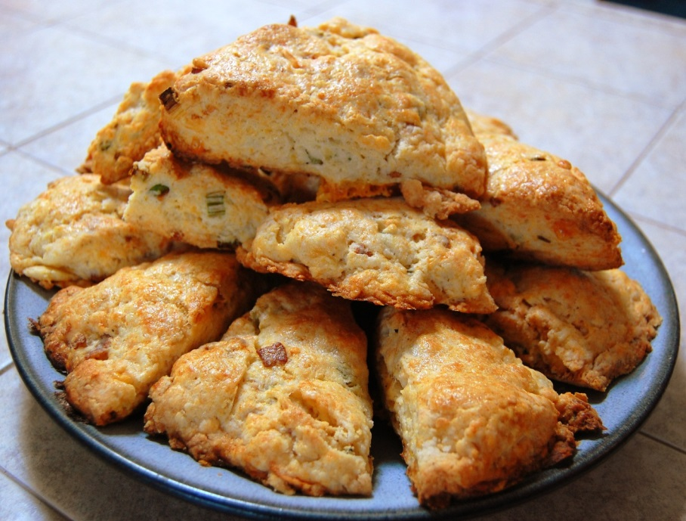

From Barbara Callanan Barbara@consultjcb.com:

Coconut Crusted Chicken Breast Bites

- 1 pound boneless, skinless chicken breasts
- 1/4 teaspoon salt
- 1/8 teaspoon ground black pepper
- 1 cup gluten-free flour of choice
- 3 large eggs
- 2 cups gluten-free panko bread crumbs
- 3/4 cup unsweetened shredded coconut
- 1/2 cup olive oil

- Method:
- Preheat the oven to 400°F. Place chicken breast on a cutting board and position a knife parallel to the cutting board. Slice chicken breast in half horizontally. Season chicken breast halves with salt and pepper. Slice each halve into vertical tenders (about 1 1/2 inches wide and 3 to 4 inches long). Place rice flour in a wide, shallow bowl. Lightly beat eggs in another shallow bowl. Combine panko and shredded coconut in a third bowl.
- Heat olive oil in a large skillet over medium-high heat. With a single hand and working with 1 piece of chicken at a time, dredge chicken in flour, shaking off excess, then dip into eggs, allowing excess to drip back into the bowl. Use your dry hand to dredge chicken in the panko-coconut mixture, pressing slightly to adhere the coating. Continue with remaining chicken.
- Fry 3 to 4 strips at a time, taking care not to overcrowd the pan, for 2 to 3 minutes on each side, until golden brown, then use a slotted spatula to transfer the chicken to a baking sheet. Repeat with remaining pieces. Bake the chicken pieces for about 5 minutes, cooked through-165 degrees. Serve immediately, with mango chutney for dipping. Serves 6

